For the Introduction to Artificial Intelligence seminar, we will need to install Python 3.7 (latest version), along with several add-on modules.

## Installing Python 3.7

* Go to <https://www.python.org/downloads/> and download the latest Python 3.7.x stable release (Python 3.7.3 as of this writing). Do not install anything greater than 3.7, as it will be incompatible with the other modules you will need. There are versions for Windows, Mac and Linux available.
* I recommend the Windows x86-64 executable installer. Download and run the installer (python-3.7.3-amd64.exe), and follow directions.
* I recommend doing a custom installation. Make sure to keep pip, IDLE, add to path, and “install for all users” selected. In particular under Advanced Options, selecting “Install for all users” will change your installation path to C:\Program Files\Python37, which is easier to find than the default installation path.
* 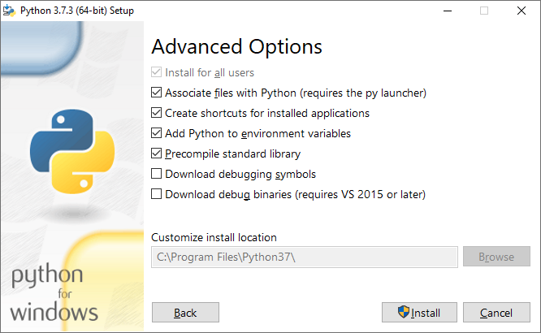
* Click on Install and wait for it to finish
* 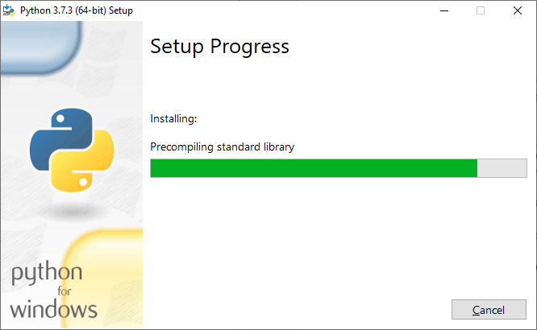
* Locate IDLE by typing “IDLE” in the Windows search bar:
* 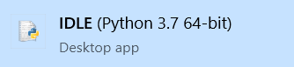
* You should get the Python IDLE interactive shell window:
* 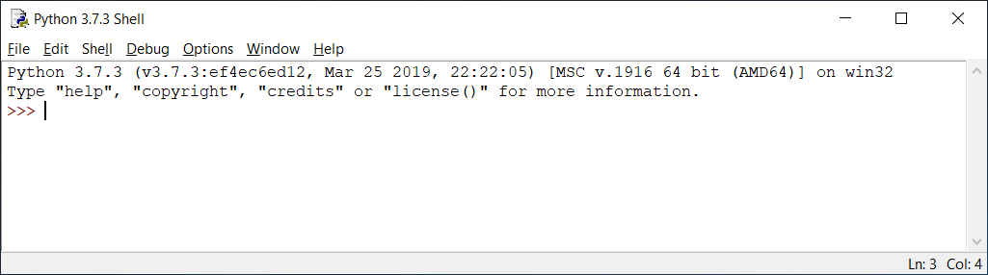

## Installing Add-on Modules

* Open a terminal window (type “cmd” in the Windows search bar). Right-click and select “Run as Administrator”
* 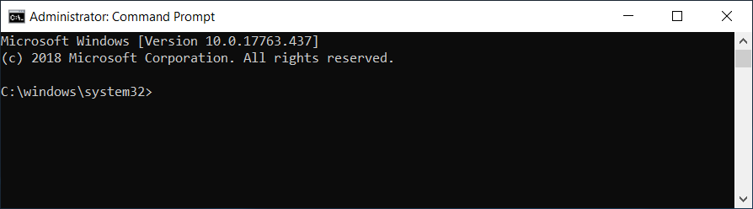
* Install the following modules:
  + pip install numpy
  + 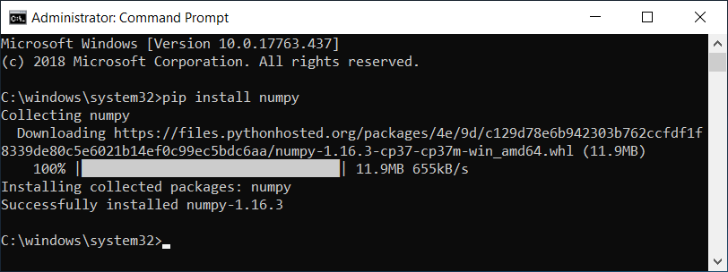
  + pip install pandas
  + pip install matplotlib
  + pip install sklearn
  + pip install tensorflow
  + pip install seaborn